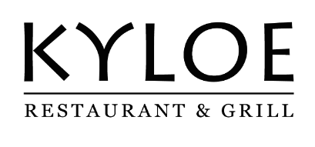

Private Dining Menu
£60

STARTERS

Scottish Monkfish Scampi
Tartare sauce, parsley & caper dressing, confit lemon, sea herbs

Whipped Inverloch Goat Cheese Millefeuille
Dressed asparagus, black truffle

Braised beef shin & Haggis Pithivier
Braised red cabbage, pickled mushrooms, peppercorn jus

Charred John Ross Smoked Salmon ‘Old Fashioned’
Burnt orange & whisky glaze, avocado creme fraiche, pickled ginger, fennel & oat cracker

~

MAIN

225g Picanha Rump Steak
beef dripping chips, baby watercress, pickled mushrooms, herb roasted tomato

Roast Lemon and Thyme chicken breast
Wilted baby spinach & pak choi, asparagus, spring onions, celeriac puree, pan jus vinaigrette

Seared Peterhead Hake
Brown shrimp, lemon, caper & chive beurre noisette, confit leek, samphire, borage

Grilled Purple Sprouting Broccoli
Broccoli & lemon puree, radishes, crisp broccoli leaves, confit garlic dressing

Additional Steak Options;
Sirloin (250g) £13
Ribeye (275g) £18
Fillet (225g) £21

~

Steak Sauces £4
whisky & peppercorn /béarnaise /
red wine & blue cheese / garlic butter

SIDES
Heritage beetroots, fennel & feta salad, sherry vinegar reduction £7.5
Roasted Chesnut mushrooms, garlic butter, parsley £7.5
Green beans, garlic & chilli dressing £7.5
Baked garlic & chive mash £7.5

~

DESSERTS

S’mores
Milk chocolate cremeux, toasted marshmallow, coco nib praline, vanilla ice cream

Citrus Meringue Tart
Sable, lemon & white chocolate curd, lemon verbena sorbet

Heather Honey Cake
Rhubarb, stem ginger tuille, rhubarb & meadowsweet sorbet

Selection of ice cream and sorbet
Ask your server for today’s flavour

If you suffer from a food allergy or intolerance, please let your server know upon placing your order. Every care is taken to avoid any cross-contamination when processing a specific allergen-free order. We do however work in a kitchen that processes allergenic ingredients and does not have a specific allergen-free zone.

